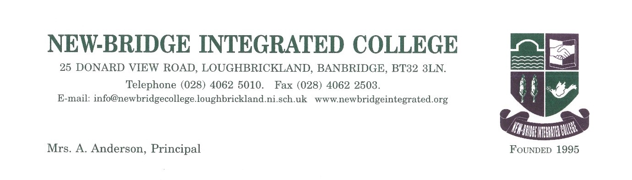

28 October 2022

Dear Parent/Guardian of P7 pupils at St Francis Primary School

New-Bridge Science and Technology Roadshow at New-Bridge Integrated College for St Francis P7 pupils

I am delighted to report that our wonderful Technology and Science Department are offering an exciting opportunity for your son/daughter to attend our new ‘New-Bridge Science and Technology Roadshow’ after school from 3.20pm-4.20pm commencing Monday 21 November 2022. Our New-Bridge Roadshow is being offered to P7 students as an after-school activity, where the students will get an opportunity to focus on the following aspects in Technology and Science:

Technology:
Pupils are invited to attend our Technology and Design workshop to learn new design and manufacturing skills. We are offering pupils the opportunity to use our wide range of equipment to manufacture a wooden tea light holder, in time for Christmas. All pupils will be working alongside a member of our Technology department, we are looking forward to helping you experience what it is like to design and manufacture your very own project. Our Technology Roadshow will run for 4 consecutive Mondays starting 21 November 2022. Students will be escorted from St Francis to New-Bridge at 3.15pm. We would ask parents/guardians to make the necessary transport arrangements to collect P7 pupils at 4.20pm.

Science:
The Science department, in conjunction with Year 8 Science ambassadors, warmly welcomes P7 pupils to join our science club. Pupils will be given the opportunity to participate in practical experiments such as testing energy content in food using our Bunsen burners. You will be invited to learn about the science behind lightening and produce your own! Finally, pupils will be given the opportunity to meet our science reptiles. Our Science Roadshow will run for 4 consecutive Wednesdays starting 11 January 2023 after school and will run for 4 weeks with same transport arrangements.

We really hope that your son/daughter can attend some, if not all, of the roadshow sessions organised as our Science and Technology department are excited about teaching as aspect of their specialist area to P7s.

As numbers are limited and we have a number of other schools taking part, I would ask you to complete the ‘Expression of Interest‘ form below and return to New-Bridge via email to elennon803@c2kni.net by Wednesday 16 November 2022 so we can finalise our numbers. Please do not hesitate to get in touch, if you have any other queries about our New-Bridge Technology and Science after school Roadshow.

Please reply by email using the Expression of Interest form provided or phone the school, if your son/daughter wishes to attend. We are very much looking forward to welcoming St Francis pupils to our school once again.
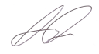
Yours sincerely
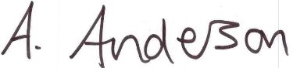

Mrs A Anderson Mr Kelly
Principal Primary Links Co-ordinator

Expression of Interest Forms

I wish to confirm that (Name of student) …………………………………………. from
St Francis Primary School would be interested in attending the after school New-Bridge Technology and Science Roadshow from 3.20pm-4.20pm.

Technology Roadshow | Science Roadshow
Monday 21 November 2022 | Wednesday 11 January 2023
Monday 28 November 2022 | Wednesday 18 January 2023
Monday 5 December 2022 | Wednesday 25 January 2023
Monday 12 December 2022 | Wednesday 1 February 2023

I will collect my child at New-Bridge each week at 4.20pm. Yes

Contact Telephone Number ……………………………….

Parent Signature ……………………………………………………

Date…………………………..

Email: elennon803@c2kni.net
Tel: 02840625010

