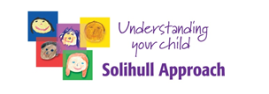

Workshop on Brain Development
Who is it for?
Parents/Carers of Adolescents living in the Southern Trust Area
(This is not a practitioner’s workshop)

What does it cover?
- Early brain and Teenage brain development
- Communicating effectively with teens
- Why risk-taking looks different to an adolescent brain
- Risk taking and friends
- Sensitivity to rejection
- Teenagers and reading faces
- Teenagers and sleep

When is it on?
- January 5th or 12th or 19th or 26th
- 7pm-9pm via zoom

How do I apply?
For further information or to book a place please contact
mona.hanna@southerntrust.hscni.net lisa.lenaghan@southerntrust.hscni.net
Please provide your name, contact number and the age of your adolescent

